**18lpi 120X240cm 3mm Lenticular Sheet for Making Strong Flip Lenticular Effect in wide Fomat**

It is suitable to make indoor lenticular printing picture, it is best for making super flip effect in wide format.  
Material: PS  
Pitch: 18.28 ~ 18.30  
Viewing angle: 36°  
Viewing distance: 1.5m~6.5m  
Standard size: 120*240cm  
Thickness: 3mm  
Effect: Super Flip  
Packing: Plywood Box  
Printed By: UV Flatprinting or injekt lamination

**25lpi 120cmx240cm 4.1mm Lenticular Sheet for Making Super 3D Effect in wide Fomat**

It is suitable to make indoor lenticular printing picture, it is best for making super 3D effect in wide format.

LPI: 25  
Material: PS  
Pitch: 25.68 ~ 25.70  
Viewing angle: 33°  
Viewing distance: 1.5m~5.5m  
Effect: Super 3D  
Thickness: 4.1 mm  
Size: W120cm*H240cm  
Packing: Plywood Box  
Printed By: UV Flatprinting or injekt lamination

**32lpi 120cmx240cm 3mm Lenticular Sheet for Making 3D Effect and Flip Effect in Middle Format Poster by Injekt and UV Flatbed Printer**

32LPI 3MM PS Lenticular sheet material  
It is suitable to make indoor lenticular printing picture, it is best for making 3D effect and Flip effect in middle format.  
Lpi: 32  
Material: PS  
Size: W120cm*H240cm  
Thickness: 3mm  
Viewing angle: 31°  
Viewing distance: 0.9m~5.0m  
Effect: 3D/Flip  
Pitch: 31.63 ~ 31.64  
Packing: Plywood Box  
Printed By: UV Flatprinting or injekt lamination

**42lpi 120X240cm 2mm Plastic Lenticular Sheet for Making 3D Effect or Flip Effect in Middle Format or Small Format by Injekt or UV Flatprint**

It is suitable to make indoor lenticular printing picture, it is best for making 3D effect and Flip effect in middle format or small format.  
Lpi: 42  
Material: PS  
Pitch: 42.30 ~ 42.32  
Size: W120cm*H240cm  
Viewing Angel: 29°  
Viewing distance: 0.9m~4.5m  
Effect: 3D/Flip  
Thickness: 2mm  
Packing: Plywood Box  
Printed By: UV Flatprinting or injekt lamination

**PET 50lpi 3D Lenticular Film 51cm X 71cm 0.6mm Lens Sheet for Injekt and UV Printer with Best 3D/Motion Printing Effect**

50lpi 0.6mm PET lenticular sheet 3d lenticular plastic films   
China Lenticular Lens 3d lenticular sheets factory  
 LPI: 50  
Material: PET  
Thickness: 0.6mm         
Size: 71cmx51cm( line direction//51cm or 71cm)  
Packaging: 200pieces in 1 carton

**75LPI 0.45mm PET lenticular sheet 3d lenticular film material  for Making 3D Lenticular Cards**

The 75 LPI lenticular lens sheet is the world-wide standard

lens design and print. It is widly used to make both 3D and

flip image lenticular effects.

Commodity: Cylinder lenticular sheet

LPI: 75

Material: PET

Viewing angle: 49 degree

Viewing distance: 0.15-1.8m

Pitch checker range:75.20-75.45 depend upon output device

Thikness: 0.45mm(450u)

Stock size: 710x510mm or 510x710mm lenticular lens parallel

to 510 or 710 dimension (510mm=20inch,710mm=28inch)

Quantity: 1500 sheets per pallet

Gross size:765x565x860mm

Custom sheets: Customized size is based on big order

Embossed lenticular: Parallel to machine direction

Surface: Top (gloss) Bottom (lenticular lens)

**PET 3D Lenticular 100lpi 0.35mm and 100lpi 0.58mm Film Sheet Lens in Size 51cm X 71cm with Super Transparency for UV Offset Printing**

100LPI 0.35mm/0.58mm PET lenticular sheet  
Tag: 100 lpi lens, lenticular lens, lenticular lens sheet, line lenticular, lenticular, 3D lens  
LPI: 100  
Material: PET

Thickness: 0.35mm or 0.58mm  
Viewing angle: 48degrees  
Viewing distance: 0.12-1.5m  
Stock size: 710X510mm or 510X710mm lenticular lens parallel to 510 or 710 Dimension: (510mm=20inch, 710mm=28inch)  
Quantity :1500 sheets per pallet  
Gross size 765X565X860mm

**3D Lenticular PET Film Lens 161lpi 51X71cm 0.25mm Lenticular Lens Sheet for Making Stickers and Tags on Offset Printing Press Machine**

Tag: 161 LPI  lens, lenticular lens, lenticular lens sheet, line lenticular, lenticular, 3D lens  
LPI: 161  
Material: PET

Thickness: 0.25  
Viewing angle: 52degrees  
Viewing distance: 0.08m-1.3m  
Stock size: 710X510mm or 510X710mm lenticular lens parallel to 510 or 710 Dimension: (510mm=20inch, 710mm=28inch)  
Quantity :1500 sheets per pallet  
Gross size 765X565X860mm

Large size 3D lenticular poster

 We can make large size 3d lenticular poster by using PS lenticular board sheet material through injekt printer or UV flatbed printer.

|  |  |
| --- | --- |
| **Commodity** | Customized 3D Lenticular billboard, 3d advertising poster, 3d wedding photo |
| **Printing Type** | Injekt print or UV flatbed print |
| **Size** | 60x80cm or 1mx2m or other size |
| **Material** | High quality of PS material. Thickness: 2mm, 3mm,4mm. |
| **Eeffect** | 3d depth effect, 2 flip, 3 flip, morph, animation, zoom |
| **Usage** | Business gift, souvenir, office or school supplies, stationary, etc. Also a good choice for Christmas Day, Valentines Day, New Year's Day, Birthday and other festivals. |
| **Design** | Designed by patented PSDTO3D101 software |
| **Delivery:** | 7-15 days |
| **File format** | JPG(300dpi or more than 300dpi) or PSD |

**OK3D PSDTO3D101 Lenticular software for making 3d flip zoom morph animation effect**

Function modify drawline & zoom layers & move point

Output file output psd and tiff

Frames 999 maxium

Effect 3d flip zoom morph animation

USB version yes

Technical support free

System All windows

1. who is the developer of this PSDTO3D software? HongMin Guo who comes from Shenzhen OK3D Technology Co., Ltd is the orignal developer of the PSDTO3D software, he has more than 10 years in 3d lenticular software development and 3d lenticular design.

2. On the interface of PSDTO3D101 software, it shows the information: Hongmin Guo, telephone No, the copyright No of this software.

Detail introduction of this PSDTO3D software as follows:

1. Modify layer drawline, for example, move, zoom in and zoom out, different layers can move, cut, paste, zoom,  point can move, add or delete

2. Angles can be 999 maxium, 2d to 3d conversion is more smooth

3. LPI and size setting are unlimited

4. Support CMYK and RGB, strong 3d effect is very clear

5. Midline can be aligned automatically

6 .Support output PSD, gif, tiff, bmp file

7.Lenticular effect can be made into 3D,flip,morph,zoom,animation

8. Support importing large size PSD file, you can make large 3d photo easily, output file can be 40GB, output DPI can be 9600 maxium

|  |  |
| --- | --- |
| effect | 3D,flip,morph,zoom,animation |
| technical support | Provide for free |
| Copyright registration No. | 2009SR039988 |
| System requirement | All windows system |

**Fly eye 3d lenticular software1 .0  3d effect 360 degrees lenticular design software for fly eye lens sheet**

This software is being used to design geometric pattern into fly eye 3d pattern, like star shape, square shape, triangle shape, it requires high definition background, it must be circularpattern, it will be made into very strong fly—eye 3d effect in all direction,  we can put 2d photo in the foreground. This software is extremely popular in packaging.

|  |  |
| --- | --- |
| effect | Fly-eye 3d in all direction |
| technical support | Provide for free |
| Copyright registration No. | 2009SR039989 |
| System requirement | All windows system |

**Anti-counterfeiting software 2.0**

Character anti-counterfeiting

Hidden logo or company information

Unable to scan yes

 1. Used for 3d anti-counterfeiting Packaging, 3d anti-counterfiting pattern design, the printing method is the same as common printing

 2. Original printing product is almost unchanged, but after putting the matched LPI lenticular sheet on the printing product, a clear hidden pattern appears, such as company logo, contact information..

3. Rotating 90 degrees, you can see different hidden pattern

|  |  |
| --- | --- |
| Commodity | 3D lenticular security software |
| Author | Hongmin Guo |
| Advantage | multi-density hybrid encryption |
| Usage | Product package, company confidential information |
| Registered No. | 2009SR051251 |
| Fuction | 3d anti-counterfeiting packaging, 3d anti-counterfiting pattern design, printing method is the same as common printing |
| Features | 1. english version, provide operation video  2. provide long time technical support  3. make your products become unique, nobody can copy it, protect your technology and patent. |

**RIP3D2.0 Lenticular Software for CMYK color separation of large 3D Photo by UV offset printing**

Main function color separation

Large photo 10G maxium

Output file CMYK file individually

3d trianning yes

USB key yes

Output DPI 9600 maxium

1. RIP3D2.0 software has been authorized through the National Copyright Administration of China. Registered No.2009SR051251

2.Merging and color separation can be done at the same time, besides, the photo is interlaced with the best DPI.

3. You can output high DPI file(1 bit tiff) with resolution 4800, the tiff file can be output quickly on the CTP machine

4. It can be printed by common printer and the effect is better than traditional technique. RIP3D 3.0 supports large image which up to 10G.

|  |  |
| --- | --- |
| Function | Separate c,m,y,k files individually |
| technical support | Provide for free |
| Copyright registration No. | 2009SR051251 |
| System requirement | All windows system |

**3D Lenticular crystal ball**

Customized Artwork Requirements:

|  |  |
| --- | --- |
| File formats | Tiff,jpg,jpeg,psd (preferably layered),pdf |
| Color | CMYK |
| Resolution | 300 dpi or higher |
| Effect: | 3d animation lenticular effect |

How to design 3d crystal ball photo : there has high definition background and spherical foreground, they are both circular pattern, they will be made into very strong 3d effect, the spherical foreground will be like 3d crystal ball, moving left to right, we can put 2d potrait in the spherical foreground

**3D Lenticular Sheet Lens with PET/PS material**

 1. Cylinder lenticular sheet has two direction: horizontal and vertical. Generally, we use "how many lines in length" to identify the size of the lenticular sheet.

2. According to the thickness and the usage of lenticular sheet, we can divide it into two kinds: lenticular lens and lenticular board

3. Lenticular lens, the LPI are 50LPI, 70LPI, 75LPI, 100LPI, 161LPI, 200LPI, standard size are 51cm*71cm or 60cm*80cm, these lenticular lens are mainly for making lenticular card, lenticular bookmark, lenticular ruler, indoor lenticular 3d poster

4. Lenticular board, the LPI are 10LPI, 18LPI, 20LPI, 25LPI, 32LPI, 42LPI, standard size is 120cm*240cm, these lenticular board are mainly for making big size outdoor 3d lenticular advertising poster,lenticular wedding poster, 3d billboard, subway 3d poster.

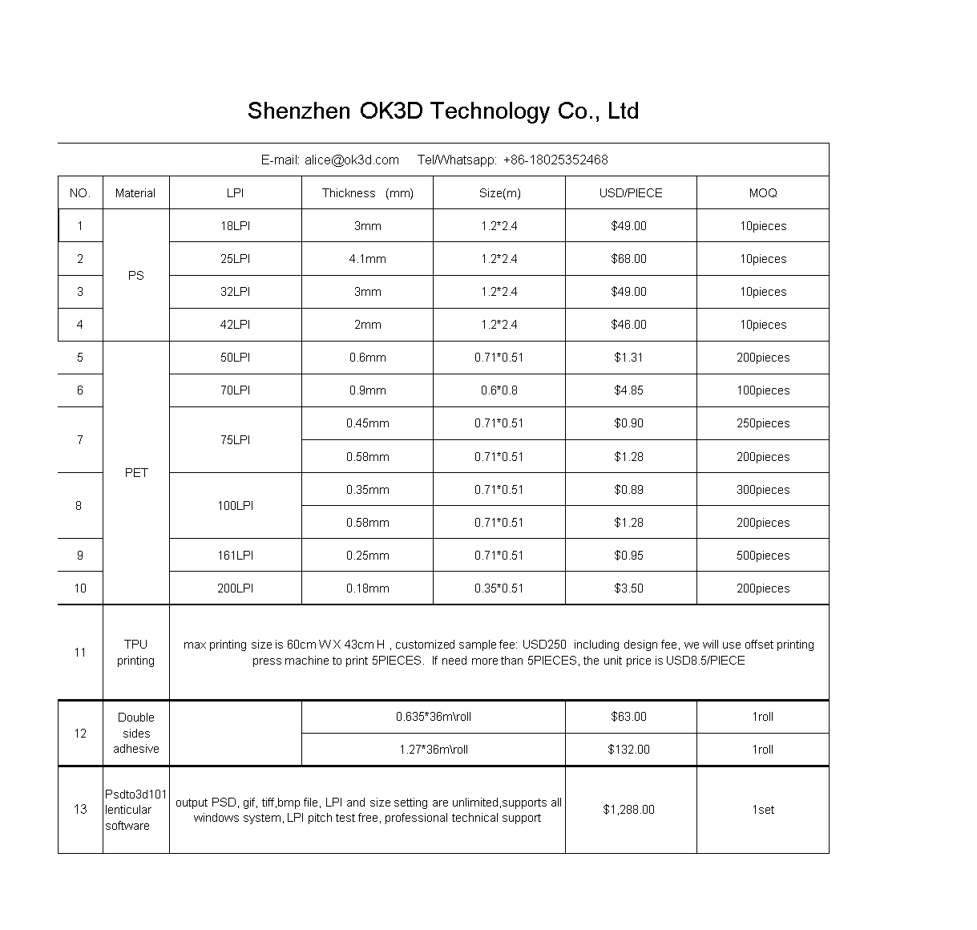

**Transparent PET double sides adhesive with thickness 0.1mm for lenticular photo lamination**

|  |  |
| --- | --- |
| Material | PET |
| Advantage | Transparent and No bubbles |
| Usage | Lenticular photo lamination |

1. Application: Firstly, print 3d photo on the paper, secondly, put the double sides adhesive between the printed paper and the lenticular sheet, thirdly, use a cold laminator to laminate the printed paper and lenticular sheet together

2.Take out release paper first, then paste printed photo paper to lenticular sheet tightly

3. high-temperature resistance

About the double sides adhesive, there has 2 size are in same quality, they are as following:

0.635mx36m/roll, the price is USD63/ROLL

1.27mx36m/roll, the price is USD132/ROLL

**TPU** has good processability, weather resistance and environmental protection, it is easy to be accepted by products and markets.It is widely used in shoes materials, clothing, bags, toys and other products industry.TPU is characterized by excellent wear resistance, high hardness, high strength, good elasticity, low temperature resistance, good oil resistance and other characteristics.

**Explanation of lenticular effect**

3D effect  
Objects within an image are layered to give the illusion of depth and perspective. Unlike 2-dimensional design, using this lenticular effect allows graphics to appear more realistic.

FLIP effect  
A dramatic swapping of two images-each vanishing and then reappearing from one to another. Utilizing this lenticular flip effect is most beneficial for demonstrating "cause-and-effect" or even "before-and-after" comparisons.  
  
MORPH effect  
The conversion of one image into another is used to create the illusion of transformation. This lenticular morph effect can be used for showcasing a product or feature that may change or create change.  
  
ZOOM effect  
The illusion of movement from background to foreground to create the effect of "leaping out" or "jumping back. " A lenticular zoom animation can consist of one or more objects, or even a full image. This effect works best for highlighting elements such as products, logos, or important messages.  
  
ANIMATION effect  
With a series of images coming together to create an animation much like a short movie clip, this is the most complex lenticular effect. The illusion of motion actually comes from either a selection of video frames or sequential still images. This lenticular animation effect is great for emphasizing body movement or mechanical action.

**Shenzhen OK3D Technology Co., Ltd**

Founded in 2004, we are specialized in 3d software development with 3d photo design and inkjet printing, 3d lenticular offset printing.. As the top one in the 3D filed, with the development and innovation of 3D industry. We have obtained many record of the first in China -- China’s first 3D lenticular mold development, China’s first 3D design software development, China’s first self-developed software market share reached 95%. At present, we have won much trust from the clients all over the world.

About 3D design software: We have perfect 3d solution in high accuracy output and large format output, output accuracy can reach 9600DPI, output size can reach 5M*5M, output speed is quite fast.

About 3D printing: That can be mainly divided into six parts:the stationery class product,Cards,Commercial advertisement,Daily Products,Packaging,Craft picture. we can convert 2d picure into 3d picture by our patented PSDTO3D101 software easily, they will show perfect lenticular effect.

About Lenticular sheet: We have different lpi lenticular for you to choice, size can be customized based on your requirement. Our lenticular sheet materials are manufactured by high quality original clear plastic materials, they are in good accuracy of focus, best colouration. The lenticular sheet materials are being used to make 3D, 3d+flip, flip, zoom, morph, animation effect, they are widly being used in outdoor large size printing and indoor small size printing.

Company culture concep: Best quality products, excellent after-sale service, the most competitive price, fast delivery.  
    
We promise :   
1. Best quality products  
2. Excellent after-sale service  
3. The most competitive price  
4. Fast delivery  
    
If you are interested in the product, please contact: Tel/Wechat:  +86-18025352468